Chapter 08: Leadership

Table of Contents

Managers vs Leaders 2

Early Leadership Theories 2

Trait Theories 2

Behavioral Theories 4

Contingency Theories of Leadership 5

Hersey and Blanchard’s Situational Leadership 5

Path-Goal Theory 7

Leading Change 9

Charismatic-Visionary Leadership 9

Transformational Leadership 10

Current Issues in Leadership 11

Managing Power 11

Developing Trust 11

## Managers vs Leaders

The difference between a **manager** and a **leader** is that a leader **copes with change** while a manager **copes with complexities**. Essentially, leaders provide vision and strategy to the organization while managers implement the vision and strategy.

Ideally, managers should be leaders but this is not always the case. Someone who is capable of motivating employees is not necessarily able to handle the complexities of managing an organization efficiently and effectively.

## Early Leadership Theories

There were several theories that attempted to understand the characteristics present in successful leaders. We will be studying two of these, trait theories and behavioral theories.

### Trait Theories

**Trait theories** attempted to identify traits that successful leaders have. Despite the best effort of researchers, they were unable to identify a set of traits that were consistently present in all leaders. However, they did identify traits present in the **process of leadership** itself. 8 such traits are listed below:

1. **Drive**: Leaders exhibit a high effort level. They have a relatively high desire for achievement; they are ambitious; they have a lot of energy; they are tirelessly persistent in their activities; and they show initiative.
2. **Desire to lead**: Leaders have a strong desire to influence and lead others. They demonstrate the willingness to take responsibility.
3. **Honesty and integrity**: Leaders build trusting relationships between themselves and followers by being truthful or non-deceitful and by showing high consistency between word and deed.
4. **Self-confidence**: Followers look to leaders for an absence of self-doubt. Leaders, therefore, need to show self-confidence in order to convince followers of the rightness of their goals and decisions.
5. **Cognitive intelligence**: Leaders need to be intelligent enough to gather, synthesize, and interpret large amounts of information, and they need to be able to create visions, solve problems, and make correct decisions.
6. **Emotional intelligence**: Leaders need to be aware of their emotions and those of others, and they need to be able to use those emotions effectively when making decisions.
7. **Job-relevant knowledge**: Effective leaders have a high degree of knowledge about the company, industry, and technical matters. In-depth knowledge allows leaders to make well-informed decisions and to understand the implications of those decisions.
8. **Extroversion**: Leaders are energetic, lively people. They are sociable, assertive, and rarely silent or withdrawn.

The traits are organized around the **big five personality framework** which consist of the following traits:

1. Extroversion
2. Agreeableness
3. Conscientiousness
4. Emotional stability
5. Openness to experience

### Behavioral Theories

**Behavioral theory** attempted to look into how leaders behave instead of inherent traits they possessed. Researchers discovered three distinct leadership styles:

1. **Autocratic** – The leader has centralized authority, dictates all work and makes unilateral decisions with little to no employee participation.
2. **Democratic** – The leader involves employees in decision making, delegates authority, encourages participation in deciding work methods and goals and uses feedback as an opportunity to coach employees.
3. **Laissez-faire** – The leader gives the group complete freedom to make decisions and complete the work in whatever way they see fit.

The results of the researchers indicates that the democratic style led to both a good quantity and good quality of work. The satisfaction of employees was highest under this style.

## Contingency Theories of Leadership

The old attempts to identify traits or behaviors were not enough to understand what made good leaders. Leaders often change their style depending on the situation. This led to more theories that attempted to describe the changing behavior.

### Hersey and Blanchard’s Situational Leadership

**Situational Leadership** focuses on **follower readiness**. The theory proposes that successful leadership is achieved by selecting the correct style depending on the **readiness** of the followers. Readiness is the extent to which people have the ability and willingness to accomplish a specific task.

Based on the readiness of the followers, leadership styles are divided into 4 types:

1. **Telling** – The leader defines roles and tells people what, how, when and where to do various tasks. The leader is heavily involved and this leads to poor relationships with the followers.
2. **Selling** – The leader provides directive and supportive behavior. They do give orders, but they also get involved with the tasks themselves. As such, the leader is heavily involved and has good relationships with the followers.
3. **Participating** – The leader and followers share in decision-making, with the main role of the leader being to facilitate and communicate. The involvement of the leader is low, but they have good relationships with the followers.
4. **Delegating** – The leader provides little direction or support, choosing to delegate authority to employees who in turn do not need the permission of the leader to take decisions. The leader is not involved and has poor relationships with their followers.

The type of leadership required depends on the readiness of the followers, which can be in one of four categories:

1. R1: Followers are both **unable** and **unwilling** to take responsibility for doing something. They are not competent nor confident.
2. R2: Followers are **unable** but **willing** to do the necessary tasks. They are motivated, but lack the required skills.
3. R3: Followers are **able** but **unwilling** to do what the leader wants.
4. R4: People are both **able** and **willing** to do what is asked.

Based on these categories, a mapping can be created for each follower readiness category with each of the leadership styles.

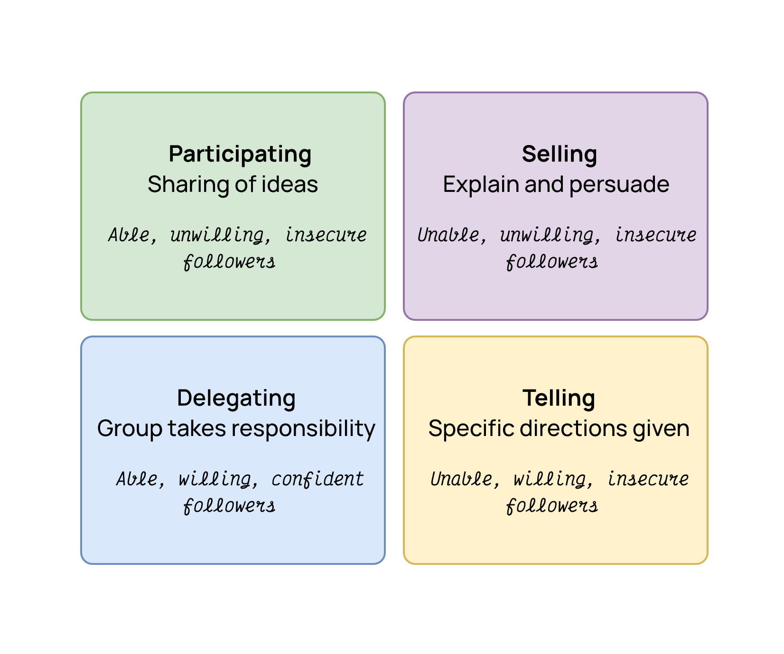

### Path-Goal Theory

According to the **path-goal theory**, the job of the leader is to assist their followers in attaining their goals. They provide the necessary direction and support to ensure that the goals are compatible with the overall objectives of the group or organization.

According to this theory, there are four leadership behaviors:

1. **Directive Leader** – Leaders let subordinates know what is expected of them, schedules work to be done and gives specific guidance on how to accomplish tasks.
2. **Supportive Leader** – Leader is friendly and shows concern for the needs of followers.
3. **Participative Leader** – Leader consults with group members and uses their suggestions before making a decision.
4. **Achievement-Oriented Leader** – Leader sets challenging goals and expects followers to perform at their highest level.

The type of behavior that should be used is controlled by two situational variables: **environment factors** (task structure, formal authority system and the work group) and the **personal characteristics of the follower** (locus of control, experience, perceived ability).

Again, the correct leadership behavior will depend on the situation presented. The chart below shows a few examples.

|  |  |  |  |
| --- | --- | --- | --- |
| **Situation** | **Leader Behavior** | **Impact on Follower** | **Outcome** |
| Follower lacks self-confidence | Supportive leadership | Increase confidence to achieve work outcome | More effort; improved satisfaction and performance |
| Ambiguous job | Directive leadership | Clarify path to reward | More effort; improved satisfaction and performance |
| Lack of job challenge | Achievement oriented leadership | Set high goals | More effort; improved satisfaction and performance |
| Incorrect reward | Participative leadership | Clarify follower's needs and change rewards | More effort; improved satisfaction and performance |

## Leading Change

The leadership theories we have studied so far fall under the category of **transactional leadership**. These are leadership styles followed by leaders who motivate their followers, clarify their tasks and achieve organizational goals. However, there are cases where a leader needs to make changes in an organization. The leadership styles we have studied so far are not enough when it comes to leading change.

To describe the leadership styles followed when inspiring change, we will be studying two more leadership types: charismatic-visionary leadership and transformational leadership.

### Charismatic-Visionary Leadership

**Charismatic** leaders have a vision, are able to articulate that vision and are willing to take risks to achieve the vision. They have the ability to inspire people to believe in their vision and influence them to behave in a manner that achieves the vision. It has been found that followers of charismatic leaders exert extra work effort while also expressing greater work satisfaction. Followers are impressed by charismatic leaders and in turn try to impress them.

Studies have taken place to see whether it is possible to teach people to be charismatic. Students were trained in things such as articulating their goals well, exhibiting confidence in the abilities of their subordinates, empathizing with the needs of their subordinates, etc. This worked to some extent as productivity among the subordinates increased.

A drawback to charismatic leadership is that there is an inherent requirement that the leader be **moral**. If not, their ability to influence others allows them to get away with unethical practices since their followers have a difficulty being critical of them.

Not every company needs a charismatic leader though. For example, a biscuit company would see little to no difference regardless of whether they did or did not have a charismatic leader. Generally, charismatic leadership is most effective in areas where there is some **ideological purpose** (such as in religion or politics) or in difficult business situations (such as a struggling business).

Although having a vision seems to be a core part of charismatic leadership, true **visionary leadership** goes beyond just charisma. It is the ability to create and articulate a realistic, credible and attractive vision of the future that improves the current situation. Visionary leaders are able to explain their vision to others, not just verbally but also through their behavior. They are able to apply the vision to different leadership contexts, such as different demographics or departments.

### Transformational Leadership

Some leaders are able to inspire people to the extent that they give up their own self-interests and drive towards a greater common goal. Such a leadership style is known as **transformational leadership**. This is somewhat similar to charismatic-visionary leadership but the key difference is that in transformational leadership people are not working for their own goals, which is the case for charismatic leadership. This difference means that transformational leaders must have a much greater influence on their followers.

## Current Issues in Leadership

### Managing Power

Leaders get their power primary through five sources:

1. **Legitimate Power** – The power attained due to having an authoritative position, such as the CEO of a company.
2. **Coercive Power** – The power attained through threat of punishment, such as the ability to fire someone for not performing well enough.
3. **Reward Power** – The power attained through the promise of rewards, such as increased wages for performing well.
4. **Expert Power** – The power attained based on domain expertise. People will trust an expert purely due to the fact that they are an expert.
5. **Referent Power** – This power attained due to admiration of followers. This is the most sensitive type of power and is the one which is most likely to be abused to manipulate followers in negative ways.

### Developing Trust

The most importing thing about being a leader is to maintain the **trust** of the followers. This is achieved through integrity, competency, consistency, loyalty and openness. If a leader loses the trust of their followers due to any reason at all, they lose all their power over them.